

**Wildlife Fact Sheet #7**

Mountain pygmy-possum *Burramys parvus*

The endangered mountain pygmy-possum *(Burramys parvus)* is a small nocturnal marsupial and an alpine-subalpine specialist – it is the only Australian mammal entirely restricted to areas above the winter snowline. It weighs just 45 grams and with body length of up to 11cm, it can easily fit in the palm of your hand. Its mouse-like body is covered in thick greyish fur, which among the slightly larger males becomes more orange during the breeding season. The possum has a long tail, very agile front feet designed for gathering food, gripping back feet and enlarged front teeth, which it uses proficiently to crack seeds.

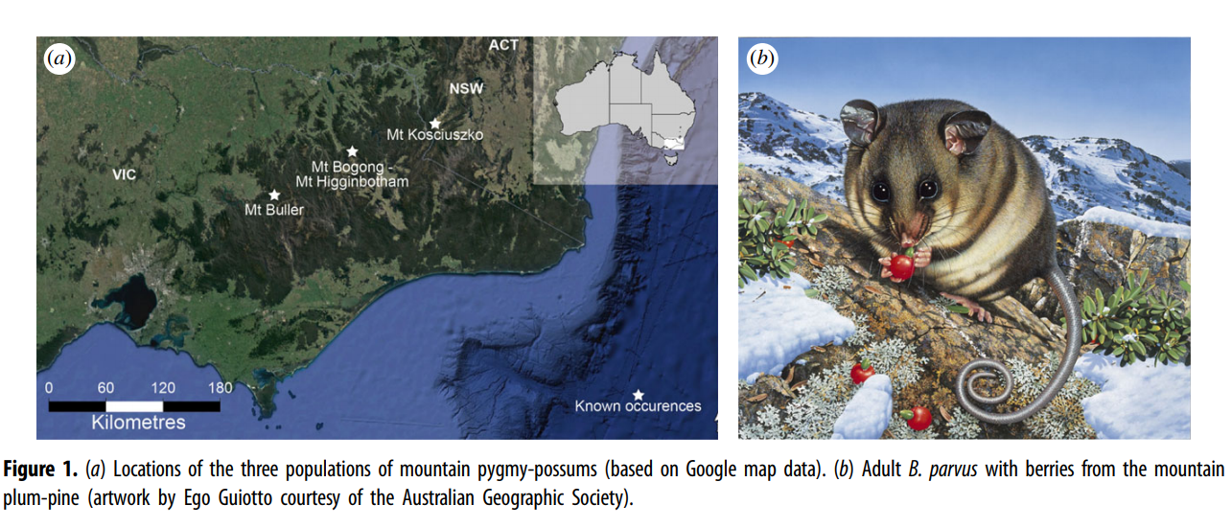

Habitat, Diet & Breeding:

The mountain pygmy-possum is found only in Australia’s snow-covered alpine and sub-alpine region above 1400 metres in the Snowy Mountains in southern New South Wales and the High Country of north-eastern Victoria. It lives among the rock crevices and boulder-fields associated with the mountain plum pine (Podocarpus lawrencei). The possum’s entire range, which largely coincides with Australia’s ski resorts, is thought to cover about 8 square kilometres.

The mountain pygmy-possum scurries about at night during the short alpine spring and summer months, building up fat reserves by feeding mostly on rich Bogong moths (Agrotis infusa). At other times of the year it is more opportunistic, supplementing this diet with the seeds and fruit of plants like the mountain plum pine, rambling bramble and snow beard-heath.

During hibernation in the snow season, between April and October, the possum feeds from a hidden cache of stored seeds and nuts. At the beginning of winter, its torpor might last for several days before the hungry possum wakes to dine. This period is extended as the winter progresses, lasting as long as three weeks during the coldest months.

One litter of two, three or four young is born annually in October or November; the young are independent by January. During the nonbreeding season, males live outside the female habitat.

Conservation Status:

There are less than 2000 mountain pygmy-possum adults left in the wild. Their habitat requirements restrict their distribution, meaning numbers cannot significantly increase.

The species was only known in fossil form until 1966, when visitors to a Mount Hotham ski lodge spied a weird little animal running around the kitchen. It was described as an animal that had ‘returned from extinction’ and one of the few Australian species that had been given ‘a second chance’. Over the next four decades the mountain pygmy-possum was located in three genetically different and isolated populations, separated by low elevation river valleys, in the subalpine and alpine region of southern NSW and eastern Victoria.

Living only above the retreating snowline, this species is in a real danger of becoming extinct due to decreased habitat from development (e.g. ski resorts, car parks), isolated subpopulations, predation from feral cats and foxes as well as shrinking supply of Bogong moths, one of its major food supplies. An estimated 4.4 billion moths normally arrive in the south-eastern Australian alpine regions each year, to escape the hotter weather in lowland south-east Australia. Since 2017 very low numbers of Bogong Moths have been migrating to the alps due to weather changes (exceptionally dry winters).

Mountain pygmy-possum now faces a new threat as the snow cover it needs for insulation during hibernation is reduced annually. Because the mountain pygmy-possum needs a snow depth of at least 1 metre to provide adequate insulation during its winter hibernation, it is threatened by any climate change that fragments or thins the snow cover and exposes it to cold temperatures. Evidence from the Snowy Mountains also suggests that feral animals are going to be more able to access higher-altitude areas, with potentially disastrous consequences for many native species, including pygmy possums. As our world warms, weeds such as blackberry and English broom are expected to have an advantage at higher altitudes, where it is feared they will encroach further on native plants and possibly cause the mountain pygmy possum to lose its competitive advantage over other small mammals like the bush rat (Rattus fuscipes).

Interesting Facts

Mountain pygmy-possum is:

* the only mammal restricted to the alpine and sub-alpine areas of mainland Australia.
* the longest-living small terrestrial mammal known (females can reach an age of more than 12 years).
* the world's only hibernating marsupial. During hibernation, the mountain pygmy possum’s metabolic rate is reduced by about 98 per cent.

The Future:

To combat the effects of climate change, a breeding program has been established at Secret Creek Sanctuary. The fossil records show that the prime habitat of the mountain pygmy-possum’s ancestors was rainforest environments. The program aims to breed the critically endangered mountain pygmy-possums at warmer, lowland rainforest conditions and lower altitude of 1000 metres. This strategy will provide the mountain pygmy-possums with the opportunity to adapt to a warmer temperature, providing it with the change for survival and preventing it from becoming a potential victim of climate change.

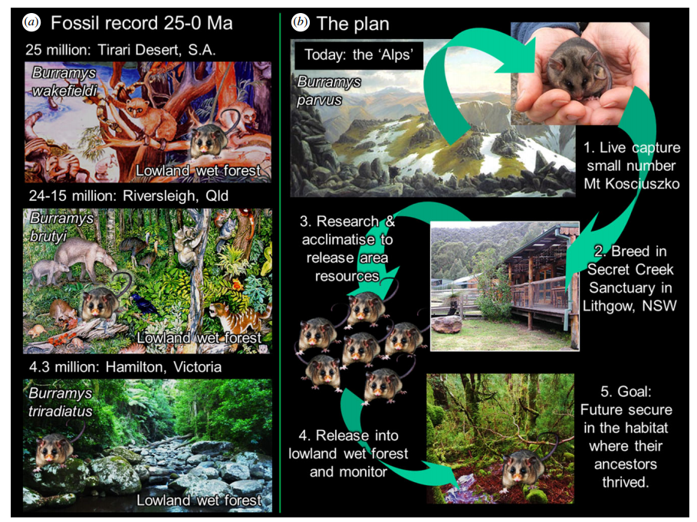

How you can help:

You can support the mountain pygmy-possum conservation programs by the Australian Ecosystems Foundation Inc through animal sponsorship, donations, or visiting our reserves. Visit our website for more details.